AI Assisted Coding

ASSIGNMENT 7.4

Name: A.vijaya karunya
HT No: 2303A52364
Batch: 32

Question 1: Mutable Default Argument – Function Bug
Task:
Analyze given code where a mutable default argument causes unexpected behavior. Use AI to fix it.
# Bug: Mutable default argument
def add_item(item, items=[]):
items.append(item)
return items
print(add_item(1))
print(add_item(2))
Expected Output: Corrected function avoids shared list bug.
Prompt:
Fix the mutable default argument issue in the function so that each call gets a fresh list.
Code:
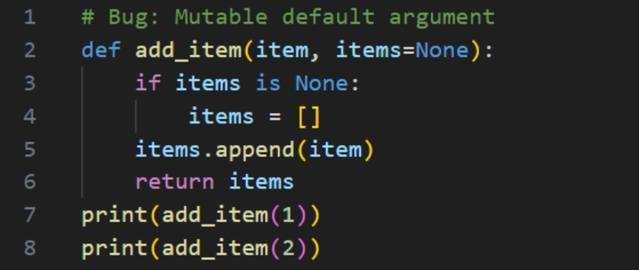

Output(O/P)


Explanation:
When a list like [] is used as a default argument, it is created only once when the function is defined, not each time the function is called. This means the same list is shared across all calls, so any changes made to it will remain for future calls. This can lead to unexpected behavior. Using None as the default value ensures that a new list is created inside the function every time it runs.

Question 2: Floating-Point Precision Error
Task:
Analyze given code where floating-point comparison fails. Use AI to correct with tolerance.
# Bug: Floating point precision issue
def check_sum():
return (0.1 + 0.2) == 0.3
print(check_sum())
Expected Output: Corrected function
Prompt:
Fix floating point comparison using tolerance.
Code:
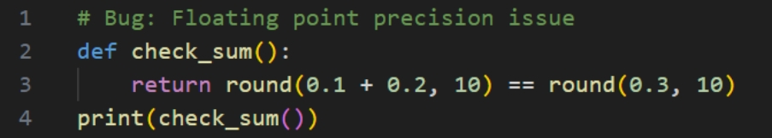 Output(O/P):

Explanation:
Decimal values cannot always be represented precisely in binary form, which can cause small rounding errors. Instead of using ==, we check if the difference between numbers is within a tiny tolerance range.

Question 3: Recursion Error – Missing Base Case
Task:
Analyze given code where recursion runs infinitely due to missing base case. Use AI to fix it.
# Bug: No base case
def countdown(n):
print(n)
return countdown(n-1)
countdown(5)
Expected Output : Correct recursion with stopping condition.
Prompt:
Add a stopping condition to prevent infinite recursion.
Code:
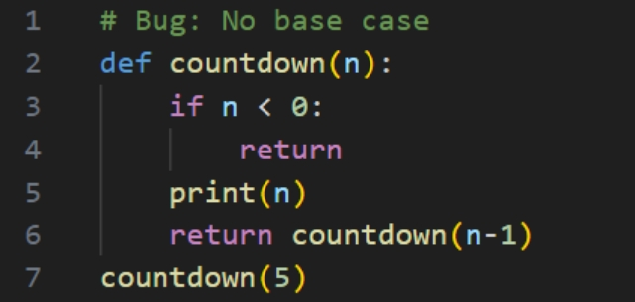
Output(O/P):
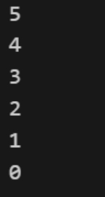

Explanation:
If a recursive function doesn’t include a stopping condition, it will continue calling itself indefinitely. Adding a base case ensures the recursion ends once n reaches 0.

Question 4: Dictionary Key Error
Task:
Analyze given code where a missing dictionary key causes error. Use AI to fix it.
# Bug: Accessing non-existing key
def get_value():
data = {"a": 1, "b": 2}
return data["c"]
print(get_value())
Expected Output: Corrected with .get() or error handling.
Prompt:
Fix missing key access safely.
Code:
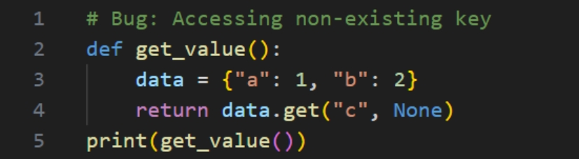 Output(O/P)

Explanation:
Trying to access data["c"] raises a KeyError if the key doesn’t exist in the dictionary. Using .get() avoids this error and lets you provide a default value instead.

Question 5: Infinite Loop – Wrong Condition
Task:
Analyze given code where the loop never ends. Use AI to detect and fix it.
# Bug: Infinite loop
def loop_example():
i = 0
while i < 5:
print(i)
Expected Output: Corrected loop increments i.
Prompt:
Fix the infinite loop by incrementing the counter.
Code:
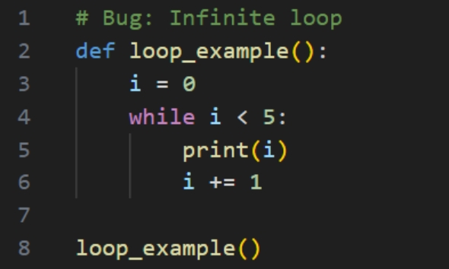
Output(O/P)

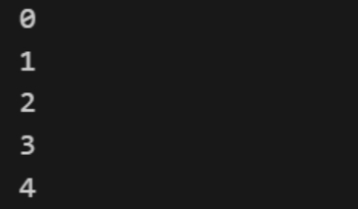

Explanation:
The variable i was not updated inside the loop, so its value never changed. As a result, the loop condition remained true and caused an infinite loop.

Question 6: Unpacking Error – Wrong Variables
Task:
Analyze given code where tuple unpacking fails. Use AI to fix it.
# Bug: Wrong unpacking
a, b = (1, 2, 3)
Expected Output: Correct unpacking or using _ for extra values.
Prompt:
Fix tuple unpacking.
Code:
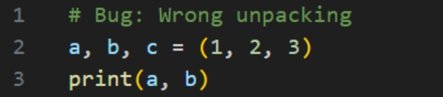
Output(O/P)


Explanation:
The tuple contained three elements, but only two variables were used to unpack them, causing a mismatch. Adding a third variable c resolves the unpacking error.

Question 7: Mixed Indentation – Tabs vs Spaces
Task:
Analyze given code where mixed indentation breaks execution. Use AI to fix it.
# Bug: Mixed indentation
def func():
x = 5
y = 10
return x+y
Expected Output : Consistent indentation applied.
Prompt:
Fix inconsistent indentation.
Code:
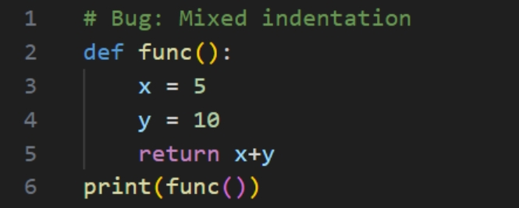

Output(O/P)

Explanation:
Python depends on uniform indentation to define code blocks correctly. Maintaining consistent spacing prevents syntax errors and ensures the program runs properly.

Question 8: Import Error – Wrong Module Usage
Task:
Analyze given code with incorrect import. Use AI to fix it.
# Bug: Wrong import
import maths
print(maths.sqrt(16))
Expected Output: Corrected to import math
Prompt:
Fix incorrect module import.
Code:
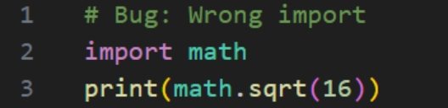
Output(O/P)


Explanation:
Corrected Typo of Import of math module

Question 9: Unreachable Code – Return Inside Loop
Task:
Analyze given code where a return inside a loop prevents full iteration. Use AI to fix it.
# Bug: Early return inside loop
def total(numbers):
for n in numbers:
return n
print(total([1,2,3]))
Expected Output: Corrected code accumulates sum and returns after loop
Prompt:
Fix early return inside loop.
Code:
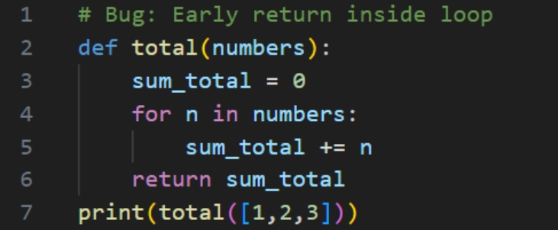
Output(O/P)


Explanation:
Return statement inside the loop stops after the first iteration.
Now it sums all elements before returning.

Question 10: Name Error – Undefined Variable
Task:
Task: Analyze given code where a variable is used before being defined. Let AI detect and fix the error.
# Bug: Using undefined variable
def calculate_area():
return length * width
print(calculate_area())
Requirements:
• Run the code to observe the error.
• Ask AI to identify the missing variable definition.
• Fix the bug by defining length and width as parameters.
• Add 3 assert test cases for correctness.
Expected Output :
• Corrected code with parameters.
• AI explanation of the bug.
Successful execution of assertions.
Prompt:
Fix undefined variables by using parameters. Add 3 assert test cases to test correctness.
Code:
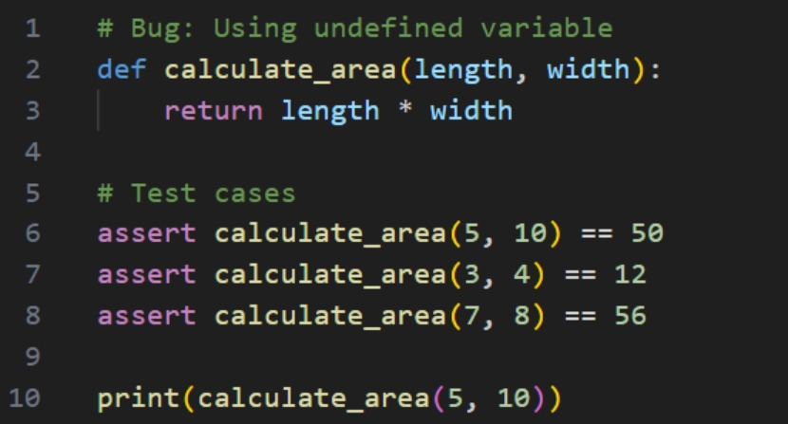

Output(O/P)

Explanation:
The variables length and width were not defined before being used, which caused a NameError. Defining them as function parameters ensures they are properly assigned values when the function is called.

Question 11: Type Error – Mixing Data Types Incorrectly

Task:
Analyze given code where integers and strings are added incorrectly. Let AI detect and fix the error.
# Bug: Adding integer and string
def add_values():
return 5 + "10"
print(add_values())
Requirements:
• Run the code to observe the error.
• AI should explain why int + str is invalid.
• Fix the code by type conversion (e.g., int("10") or str(5)).
• Verify with 3 assert cases.
Expected Output #6:
• Corrected code with type handling.
• AI explanation of the fix. Successful test validation.
Prompt:
Fix int adding string error using conversion. Add 3 assert test cases to test correctness, explain in a docstring why int + str is invalid.
Code:
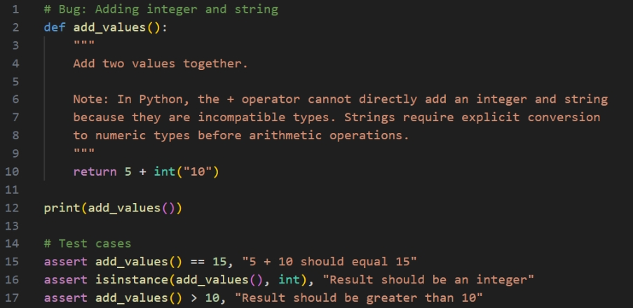 Output(O/P)


Explanation:
Python does not allow direct addition of an integer and a string because they are different data types. Converting one value to match the other type resolves the error and allows the operation to work properly.
Question 12: Type Error – String + List Concatenation
Task:
Analyze code where a string is incorrectly added to a list.
# Bug: Adding string and list
def combine():
return "Numbers: " + [1, 2, 3]
print(combine())
Requirements:
• Run the code to observe the error.
• Explain why str + list is invalid.
• Fix using conversion (str([1,2,3]) or " ".join()).
• Verify with 3 assert cases.
Expected Output:
• Corrected code
• Explanation
• Successful test validation
Prompt:
Fix string + list concatenation using conversion, Add 3 assert test cases to test correctness, explain in a docstring why str + list is invalid.
Code:
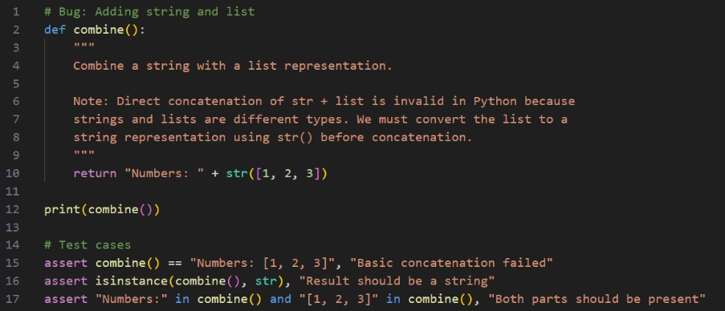 Output(O/P)


Explanation:
You cannot directly concatenate a string with a list because they are different data types. Convert the list into a string format first before combining it with a string.

Question 13: Type Error – Multiplying String by Float
Task:
Detect and fix code where a string is multiplied by a float.
# Bug: Multiplying string by float
def repeat_text():
return "Hello" * 2.5
print(repeat_text())
Requirements:
• Observe the error.
• Explain why float multiplication is invalid for strings.
• Fix by converting float to int.
• Add 3 assert test cases.
Prompt:
Fix string multiplied by float using conversion, Explain in a docstring why float multiplication is invalid for strings, Add 3 assert test cases.
Code:
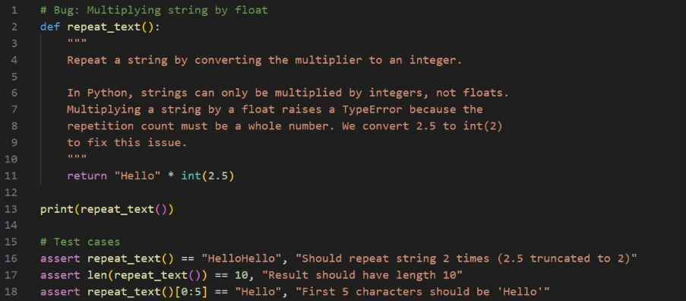 Output(O/P)

Explanation:
A string can be repeated only when multiplied by an integer, not a float. So, convert the float value to an integer before performing the multiplication.
Question 14: Type Error – Adding None to Integer
Task:
Analyze code where None is added to an integer.
# Bug: Adding None and integer
def compute():
value = None
return value + 10
print(compute())
Requirements:
• Run and identify the error.
• Explain why NoneType cannot be added.
• Fix by assigning a default value.
• Validate using asserts.
Prompt:
Fix None addition issue, Explain in a docstring why NoneType cannot be added, Validate using asserts.
Code:
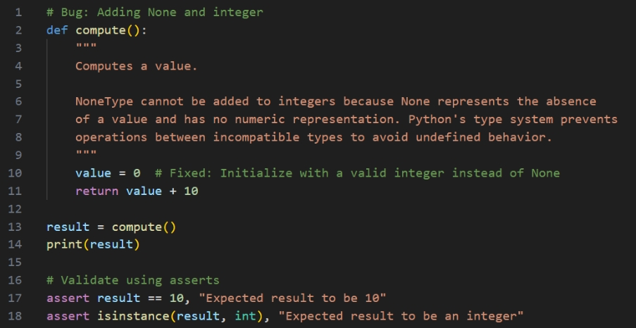
Output(O/P)

Explanation:
You cannot perform addition between None and an integer because None is not a numeric value. Make sure to assign a valid number before doing arithmetic operations.

Question 15: Type Error – Input Treated as String Instead of Number
Task:
Fix code where user input is not converted properly.
# Bug: Input remains string
def sum_two_numbers():
a = input("Enter first number: ")
b = input("Enter second number: ")
return a + b
print(sum_two_numbers())
Requirements:
• Explain why input is always string.
• Fix using int() conversion.
• Verify with assert test cases.
Prompt:
Fix input conversion issue using type conversion, Explain in docstring why input is always string, Verify with assert test cases.
Code:
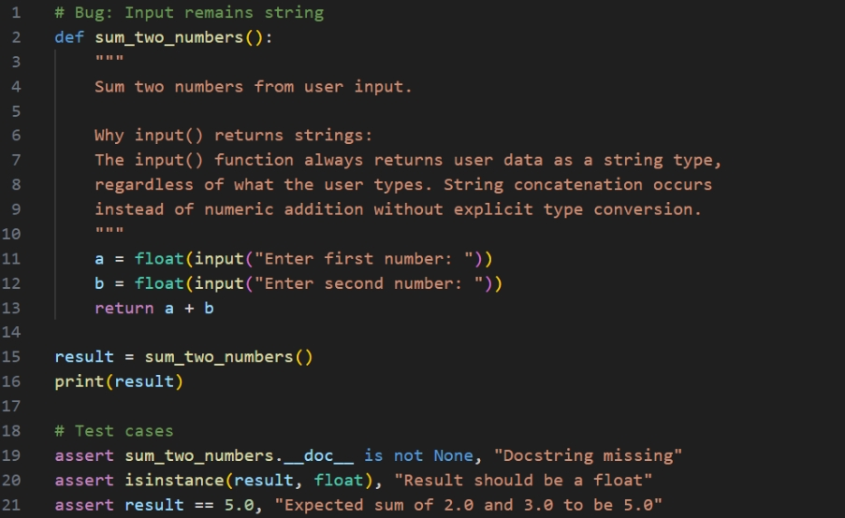

Output(O/P)

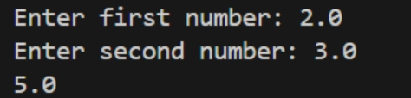
Explanation:
The input() function returns data as a string by default. To perform calculations, you must convert it to int or float first.

